ISAM 5931 Assignment 3

Download the Texas Airbnb file and complete the following questions.

Q1. Read the csv file and load the data into a DataFrame named airbnb. Make the first column of the data in the file as Index (the row ids of 1, 2, 3……). Use the first row of the data in the file as the columns’ names. Display the first 5 rows.

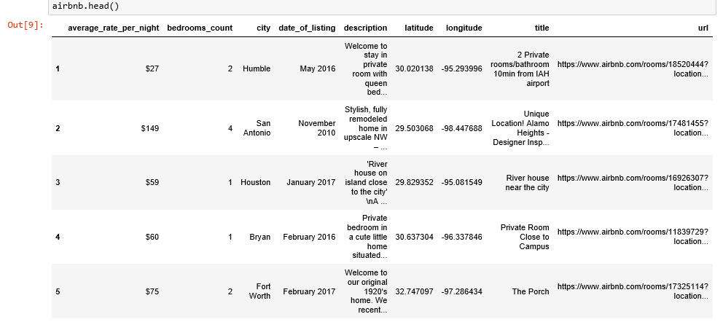

Q2. Display only True or False (not an array of Boolean values) for whether or not there is any NaN for average price per night.

Q3. Display the rows (with all columns in airbnb) that have missing average rates.

Q4. Display the rows (with all columns in airbnb) that have missing bedrooms count.

Q5. IN THE ORIGINAL DataFrame airbnb, drop the rows that have either missing average rate OR bedrooms count. You can drop rows with NaN in a specific column or columns by using the following syntax df.dropna(subset = [‘theColumnName’]), suppose that df is the variable of the DataFrame.

Q6. IN THE ORIGINAL DataFrame, replace the NaNs in the columns of city, date of listing, description, title and url to a string of “Not Available”. Do not drop the rows with NaNs in these columns.

Q7. IN THE ORIGINAL Dataframe, convert the average price to be integers. Display the first 5 rows.

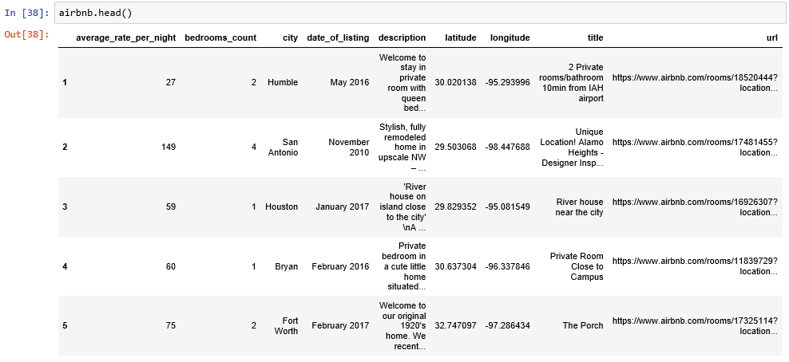

Q8. Determine whether or not there is any negative number in the average price column. If yes, replace the value with NaN and then drop the rows. Then, or if no negative values, calculate a mean of the average price for all properties.

Q9. I want to know how many kinds of properties it has. Display the types of bedrooms_count or the number of unique values in bedrooms_count.

Q10. I also want to know whether or not there is any Studio property. Display True or False for it. If True, calculate the average price per night for the Studio properties.

Q11. I also want to know the average price of the properties with the largest number of bedrooms count in the dataset. Obtain the largest number of bedrooms count from the values in Q9.

Q12. I am interested in the minimum price, maximum price and average price of a 2 bedroom property in Houston. Display the values, respectively.